5. DFS

Aim:
To implement the Depth-First Search (DFS) algorithm using Python to traverse a graph.

Objective :
- To understand the Depth-First Search (DFS) algorithm.
- To traverse all the vertices of a graph using a stack.
- To visit each node exactly once.
- To display the DFS traversal order.

Algorithm:

- Start.
- Create a graph using an adjacency list.
- Create an empty visited list and an empty stack.
- Choose the starting node.
- Push the starting node onto the stack.
- Repeat until the stack becomes empty:
- Pop the top node from the stack.
- If the node has not been visited:
  - Mark it as visited.
  - Display the node.
  - Push all unvisited adjacent nodes onto the stack in reverse order.
- Stop.

Flowchart :

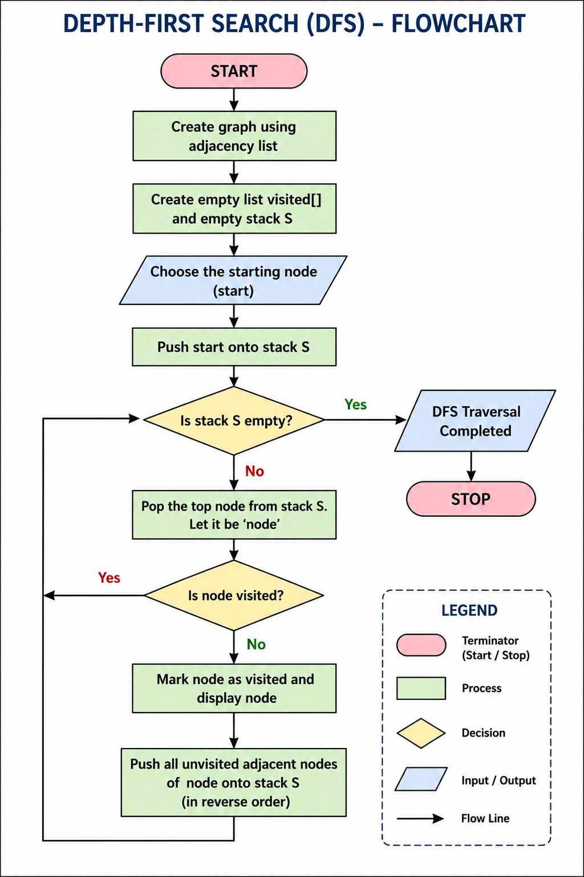

Code:
graph = {
'A': ['B', 'C'],
'B': ['D', 'E'],
'C': ['F'],
'D': [],
'E': ['F'],
'F': []
}
visited = []
stack = []
start = 'A'
stack.append(start)
print("DFS Traversal:")
while stack:
node = stack.pop()
if node not in visited:
print(node, end=" ")
visited.append(node)
for neighbour in reversed(graph[node]):
if neighbour not in visited:
stack.append(neighbour)

Output:
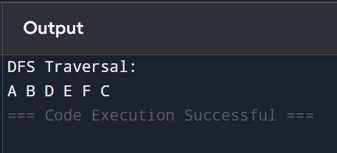

Result :
The Depth-First Search (DFS) algorithm was successfully implemented using Python. The graph was traversed by exploring each branch as deeply as possible before backtracking, and the traversal order was displayed successfully.

